NUCLEAR SAFETY LEADERSHIP COMMITMENT STATEMENT  NSS-04c | Nuclear Governance | This is a controlled document displayed at [Company Name] | 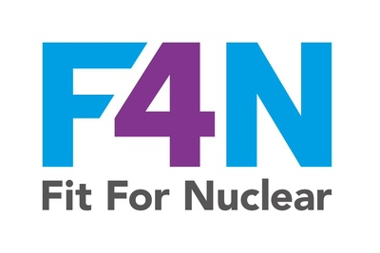

OUR COMMITMENT
[Company Name] is committed to nuclear safety as the overriding priority in all activities within the nuclear supply chain.
We will never allow commercial, schedule, or operational pressures to compromise the quality of our nuclear work or the safety of the people and environment that depend upon it.

WE SPECIFICALLY COMMIT TO:
1 | Visible leadership on nuclear safety  Our senior leaders will be present in work areas, asking nuclear quality questions, conducting planned safety walkdowns, and demonstrating through their own actions that nuclear safety is the overriding priority.
2 | Clear governance and accountabilities  We will maintain a formally documented nuclear governance structure, with named individuals holding specific accountabilities and decision-making authorities for nuclear activities.
3 | Rigorous nuclear quality management  We will implement and maintain a Quality Management System that meets the requirements of ISO 19443, including SQEP records, nuclear NCR management, lifetime quality records, and CFSI controls.
4 | A safe and open reporting culture  Every person in this organisation has the right and responsibility to raise nuclear safety and quality concerns. We will maintain an independent route for concerns to be raised, and no one will face retaliation for raising a concern in good faith.
5 | Continuous learning and improvement  We will actively monitor and learn from our own experience, from industry alerts and OPEX, and from the results of our own oversight activities, and use this learning to continuously improve our nuclear quality performance.

SIGNED ON BEHALF OF [COMPANY NAME]:
Name:
Title / Role:
Signature:
Date:

This statement should be displayed in the reception, boardroom, and key production areas. Controlled copy. Review annually. NSS-04c Rev 1.0

